CS 499 Module One Assignment

- Self-Introduction: Address all of the following questions to introduce yourself.

  - How long have you been in the Computer Science program?

I have been in the computer science program for about 2 years.

  - What have you learned while in the program? List three of the most important concepts or skills you have learned.

- Encapsulation and Architecture: By applying software engineering principles to design maintainable, modular, and secure codebases.

- Performance Optimization: By selecting and implementing efficient data structures and algorithms to solve complex problems.

- Database Design and Indexing: Structuring relational or non-relational databases effectively and using strategies like indexing to optimize query performance.

  - Discuss the specific skills you aim to demonstrate through your enhancements to reach each of the course outcomes.
- Full Stack System Architecture and Secure API Design: Designing server-side routing, database schema mapping, and security authentication protocols using frameworks such as Node.js, Express, and Angular.
- Algorithmic Logic and Reinforcement Learning: Implementing decision-making loops, state-space management, and optimization algorithms, such as Q-learning agents, to solve navigation and computational problems.
- Low-level code analysis and vulnerability mitigation: Analyzing compiled assembly instructions, tracking memory buffers, and translating C++ code blocks to identify and resolve software security flaws.
  - How do the specific skills you will demonstrate align with your career plans related to your degree?
These specific skills support full-stack development and software engineering roles. This demonstrates secure routing, input validation, and API authentication, allowing me to build applications that protect user data and scale in professional environments. Working with algorithmic logic built a core of computational thinking that supports complex problem-solving, optimization, and backend performance. I also have a stronger understanding of indexing and query optimization, which demonstrates both proficiency and integrity. This mitigates latency and ensures that daily priorities are optimized.

  - How does this contribute to the specialization you are targeting for your career?
This can tie back perfectly to a specialization in software engineering and full-stack development, reinforcing how secure system architecture, efficient algorithmic logic, and robust database management prepare for highly scalable and user-ready applications.
- ePortfolio Set Up:

  - Submit a screen capture of your ePortfolio GitHub Pages home page that clearly shows your URL.

    - You already have a repository in GitHub where you uploaded projects in previous courses. Your ePortfolio will reside in GitHub but can link to work at other sites, such as Bitbucket.

  - Use the GitHub Pages link in the Resource section for directions on:
    - How to create your GitHub website and publish code to GitHub Pages
    - Issues, such as adding links to other sites

  - Paste a screenshot of your GitHub Pages home page with your URL clearly shown in the space below.

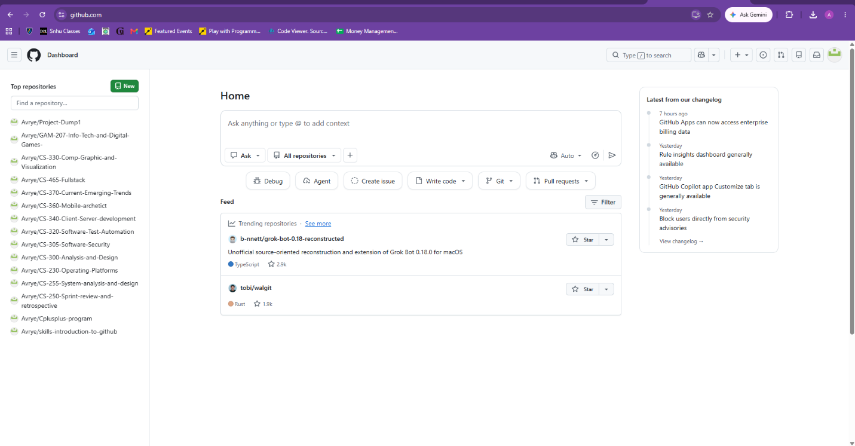

- Enhancement Plan:

  - Category One: Software Engineering and Design
    - Select an artifact that is aligned with the software engineering and design category and explain its origin. Submit a file containing the code for the artifact you choose with your enhancement plan.
The artifact that I want to enhance is CS-320 Software Test and Automation from my SNHU coursework. This project was focused on building and developing object-oriented classes, along with testing for validation through unit tests.

    - Describe a practical, well-illustrated plan for enhancement in alignment with the category, including a pseudocode or flowchart that illustrates the planned enhancement.
My enhancement plan is to refactor the core application classes to help improve data encapsulation, implement comprehensive input exception handling for edge cases, and expand on the JUnit test suite to achieve better code coverage. I also plan to expand these tests to help validate secure object states.

Psudeocode:

CLASS Item
PRIVATE properties (ID, name, description, price)

PUBLIC method updateItem(newID, newname, newPrice)
IF newID IS NULL OR TRIM(newID) EQUALS “” THEN
Throw IllegalArgumentException(“ID cannot be empty”)
END IF

IF newPrice <= 0 THEN
Throw IllegalArgumentException(“Price must be greater than zero”)
ELSE
Price = newPrice
END IF

ID = newID
Name = newname
END METHOD

PUBLIC method setPrice(newPrice)
IF newPrice <= 0 THEN
THEN throw IllegalArgumentException
ELSE
price = newPrice
END IF
END METHOD
END CLASS

For this category of enhancement, consider improving a piece of software, transferring a project into a different language, reverse engineering a piece of software for a different operating system, or expanding a project’s complexity. These are just recommendations. Consider being creative and proposing an alternative enhancement to your instructor.

Think about what additions to include to complete the enhancement criteria in this category. Since one example option is to port to a new language, that is the kind of scale that is expected. This does not mean you need to port to a new language but instead have an equivalent scale of enhancement. Underlying expectations of any enhancement include fixing errors, debugging, and cleaning up comments, but these are not enhancements themselves.

    - Explain how the planned enhancement will demonstrate specific skills and align with course outcomes.

      - Identify and describe the specific skills you will demonstrate that align with the course outcome.

This demonstrates software design and engineering principles by building maintainable and robust code structures. By applying professional testing methodologies, this will help eliminate bugs and vulnerabilities.

      - Select one or more of the course outcomes below that your enhancement will align with.

- Design and evaluate computing solutions that solve a given problem using algorithmic principles and computer science practices and standards appropriate to its solution while managing the trade-offs involved in design choices.
- Demonstrate an ability to use well-founded and innovative techniques, skills, and tools in computing practices for the purpose of implementing computer solutions that deliver value and accomplish industry-specific goals.
- Develop a security mindset that anticipates adversarial exploits in software architecture and designs to expose potential vulnerabilities, mitigate design flaws, and ensure privacy and enhanced security of data and resources.

Course Outcomes:

- Employ strategies for building collaborative environments that enable diverse audiences to support organizational decision-making in the field of computer science.
- Design, develop, and deliver professional-quality oral, written, and visual communications that are coherent, technically sound, and appropriately adapted to specific audiences and contexts.
- Design and evaluate computing solutions that solve a given problem using algorithmic principles and computer science practices and standards appropriate to its solution while managing the trade-offs involved in design choices.
- Demonstrate an ability to use well-founded and innovative techniques, skills, and tools in computing practices for the purpose of implementing computer solutions that deliver value and accomplish industry-specific goals.
- Develop a security mindset that anticipates adversarial exploits in software architecture and designs to expose potential vulnerabilities, mitigate design flaws, and ensure privacy and enhanced security of data and resources.

  - Category Two: Algorithms and Data Structures

- Select an artifact that is aligned with the algorithms and data structures category and explain its origin. Submit a file containing the code for the artifact you choose with your enhancement plan. You may choose work from the courses listed under Category One.

The artifact I chose is CS-300-Analysis-and-Design from my SNHU coursework. This was originally focused on organizing data structures and implementing sorting and searching algorithms to manage datasets.

- Describe a practical, well-illustrated plan for enhancement in alignment with the category, including a pseudocode or flowchart that illustrates the planned enhancement.

I plan to optimize the existing search and sorting logic to improve time and complexity. I also want to implement explicit performance tracking metrics, such as a time measurement to monitor resource efficiency.

Psudeocode:

FUNCTION optimizedSearch(targetID, sortedCollection)
INITALIZE low = 0, high = length(sortedCollection) – 1
WHILE low <= high DO
Mid = low + (high – low) / 2
IF sortedCollection[mid].id == targetID THEN
RETURN mid
ELSE IF sortedCollection[mid]. Id < targetID THEN
Low = mid + 1
ELSE
High = mid – 1
END IF
END WHILE
RETURN NOT_FOUND
END FUNCTION

For this category of enhancement, consider improving the efficiency of a project or expanding the complexity of the use of data structures and algorithms for your artifact. These are just recommendations. Consider being creative and proposing an alternative enhancement to your instructor. Note: You only need to choose one type of enhancement per category.

Think about what additions to include to complete the enhancement criteria in this category. Since one example option is to port to a new language, that is the kind of scale that is expected. Perhaps you might increase the efficiency and time complexity of an algorithm in an application and detail the logic of the increased time complexity. Remember, you do not need to port to a new language but instead have an equivalent scale of enhancement. Underlying expectations of any enhancement include fixing errors, debugging, and cleaning up comments, but these are not enhancements themselves.

- Explain how the planned enhancement will demonstrate specific skills and align with course outcomes.

  - Identify and describe the specific skills you will demonstrate to align with the course outcome.

This helps illustrate algorithmic principles, computational efficiency tracking, and the ability to evaluate and select appropriate data structures for optimal software performance.

  - Select one or more of the course outcomes listed under Category One that your enhancement will align with.

- Design and evaluate computing solutions that solve a given problem using algorithmic principles and computer science practices and standards appropriate to its solution while managing the trade-offs involved in design choices.
- Demonstrate an ability to use well-founded and innovative techniques, skills, and tools in computing practices for the purpose of implementing computer solutions that deliver value and accomplish industry-specific goals.

  - Category Three: Databases

    - Select an artifact that is aligned with the databases category and explain its origin. Submit a file containing the code for the artifact you choose with your enhancement plan. You may choose work from the courses listed under Category One.
The artifact I chose is CS-340 Client Server Development from my SNHU coursework. This is a mix of both Python and MongoDB, including the database pipeline and a client-server dashboard interface.

    - Describe a practical, well-illustrated plan for enhancement in alignment with the category, including a pseudocode or flowchart that illustrates the planned enhancement.
For my enhancement plan, I plan to optimize data querying by introducing specialized indexes. I will implement rigorous schema validation constraints to prevent malformed injections and secure the backend API routes handling data exchanges.

PSUDEOCODE
FUNCTION secureDatabaseQuery(clientInput)
VALIDATE schemaConstraints(clientInput)

SET queryCriteria = BUILD_SAFE_PARAMETER(“targetField”, clientInput)
SET queryOptions = USE_INDEX(“targetField_idx”)

SET recordMatchFound = DATABASE.collection.find(queryCriteria, queryOptions)

IF recordMatchFound IS NOT NULL THEN
RETURN TRANSFORM_TO_SECURE_DTO(recordMatchFound)
ELSE
RETURN safeEmptyResponse
END IF
END FUNCTION

For this category of enhancement, consider adding more advanced concepts of MySQL, incorporating data mining, creating a MongoDB interface with HTML/JavaScript, or building a full stack with a different programming language for your artifact. These are just recommendations; consider being creative and proposing an alternative enhancement to your instructor. Note: You only need to choose one type of enhancement per category.

Think about what additions to include to complete the enhancement criteria in this category. Since one example option is to port to a new language, that is the kind of scale that is expected. Perhaps you might increase the efficiency and time complexity of an algorithm in an application and detail the logic of the increased time complexity. Remember, you do not need to port to a new language but instead have an equivalent scale of enhancement. Underlying expectations of any enhancement include fixing errors, debugging, and cleaning up comments, but these are not enhancements themselves.
    - Explain how the planned enhancement will demonstrate specific skills and align with course outcomes.

      - Identify and describe the specific skills you will demonstrate that align with the course outcome.

Demonstrates database management proficiency, secure data handling, and the design of resilient client-server pipelines that safeguard backend assets.

      - Select one or more of the course outcomes listed under Category One that your enhancement will align with.

- Design and evaluate computing solutions that solve a given problem using algorithmic principles and computer science practices and standards appropriate to its solution while managing the trade-offs involved in design choices.
- Demonstrate an ability to use well-founded and innovative techniques, skills, and tools in computing practices for the purpose of implementing computer solutions that deliver value and accomplish industry-specific goals.
- Develop a security mindset that anticipates adversarial exploits in software architecture and designs to expose potential vulnerabilities, mitigate design flaws, and ensure privacy and enhanced security of data and resources.

- ePortfolio Overall Skill Set

  - Accurately describe the skill set to be illustrated by the ePortfolio overall.
    - Skills and outcomes planned to be illustrated in the code review

Code Review & Quality Assurance: I will show clean object-oriented refactoring along with disciplined unit testing. I will also show an understanding of secure data handling across Java, Python, and database layers, proving an ability to maintain code reliability.

    - Skills and outcomes planned to be illustrated in the narratives

Professional Narratives: I will show clear design choices, architectural evolution, along with structured problem-solving ideas that will help bridge academic coursework into production-ready software.

    - Skills and outcomes planned to be illustrated in the professional self-assessment

Professional Self-Assessment: This ePortfolio will highlight my technical growth across software engineering, efficiency in algorithms, and database security, demonstrating readiness for professional computer science tracks.

